Final Report
Submitted to the Embedded Systems Competition (ESC)
of SBESC 2024

Project Title：

Students:
Professor:
University:
JEMS ID:
Link to video:

Declaration of Originality

We hereby declare that this report and the work reported herein was composed and originated entirely by ourselves. Information derived from the published and unpublished work of others has been acknowledged in the text and a list of citations is given in the references section

Professor’s Signature: _____________________________________
Name (in Block Letters):
Student’s Signature: _____________________________________
Name (in Block Letters):
Student’s Signature: _____________________________________
Name (in Block Letters):
Student’s Signature: _____________________________________
Name (in Block Letters):

Date:

Abstract

Sample text format.
HCCI (Homogenous Charge Compression Ignition) combustion has advantages in terms of efficiency and reduced emission. HCCI combustion can not only ensure both the high economic and dynamic quality of the engine, but also efficiently reduce the NOx and smoke emission. Moreover, one of the remarkable characteristics of HCCI combustion is that the ignition and combustion process are controlled by the chemical kinetics, so the HCCI ignition time can vary significantly with the changes of engine configuration parameters and operating conditions. In this work numerical scheme for the ignition and combustion process of DME homogeneous charge compression ignition is studied. The detailed reaction mechanism of DME proposed by American Lawrence Livermore National Laboratory (LLNL) and the HCT chemical kinetics code developed by LLNL are used to investigate the ignition and combustion processes of an HCCI engine fueled with DME. The new kinetic mechanism for DME consists of 79 species and 399 reactions. To consider the effect of wall heat transfer, a wall heat transfer model is added into the HCT code. By this method, the effects of the compression ratio, the fuel-air equivalence ratio, the intake charge heating, the engine speed, EGR and fuel additive on the HCCI ignition and combustion are studied. The results show that the HCCI combustion fueled with DME consists of a low temperature reaction heat release period and a high temperature reaction heat release period. It is also founded that increasing the compression ration, the equivalence ratio, the intake charge temperature and the content of H2O2, H2 or CO cause advanced ignition timing. Increasing the engine speed, adoption of cold EGR and the content of CH4 or CH3OH will delay the ignition timing.

Keywords: HCCI, chemical kinetics, numerical simulation, DME, EGR

Content

1. Introduction 6
1.1 Introduction 6
1.1.1 Introduction 6
2. System Description 7
2.1 System Description 7
2.1.1 System Description 7
3. System Implementation 8
4. Results 9
5. Conclusion 10
References 11

1. Introduction
Include in this section: Objectives, project rationale, application areas.
Sample text format.
HCCI (Homogenous Charge Compression Ignition) combustion has advantages in terms of efficiency and reduced emission. HCCI combustion can not only ensure both the high economic and dynamic quality of the engine, but also efficiently reduce the NOx and smoke emission. Moreover, one of the remarkable characteristics of HCCI combustion is that the ignition and combustion process are controlled by the chemical kinetics, so the HCCI ignition time can vary significantly with the changes of engine configuration parameters and operating conditions. In this work numerical scheme for the ignition and combustion process of DME homogeneous charge compression ignition is studied.
The new kinetic mechanism for DME consists of 79 species and 399 reactions. To consider the effect of wall heat transfer, a wall heat transfer model is added into the HCT code. By this method, the effects of the compression ratio, the fuel-air equivalence ratio, the intake charge heating, the engine speed, EGR and fuel additive on the HCCI ignition and combustion are studied. The results show that the HCCI combustion fueled with DME consists of a low temperature reaction heat release period and a high temperature reaction heat release period. It is also founded that increasing the compression ration, the equivalence ratio, the intake charge temperature and the content of H2O2, H2 or CO cause advanced ignition timing. Increasing the engine speed, adoption of cold EGR and the content of CH4 or CH3OH will delay the ignition timing.

1.1 Introduction
HCCI (Homogenous Charge Compression Ignition) combustion has advantages in terms of efficiency and reduced emission. HCCI combustion can not only ensure both the high economic and dynamic quality of the engine, but also efficiently reduce the NOx and smoke emission.

1.1.1 Introduction
HCCI (Homogenous Charge Compression Ignition) combustion has advantages in terms of efficiency and reduced emission. HCCI combustion can not only ensure both the high economic and dynamic quality of the engine, but also efficiently reduce the NOx and smoke emission.：

2. System Description

2.1 System Description
…

2.1.1 System Description

See equation template in equation (2-1). In Table 2-1 one can see table template and in Figure 2-1 one can see figure template.
$m= \sum_{k=1}^{K}{}m_{k} (2-1)$

Table 2-1

Item | H_{f}(kcal/mol) | S_{f}(kcal/mol) | C_{p}(kcal/mol)
A1 | 100 | 100 | 100
A2 | 200 | 200 | 200
A3 | 300 | 300 | 300
A4 | 400 | 400 | 400
A5 | 500 | 500 | 500
A6 | 600 | 600 | 600
A7 | 700 | 700 | 700
A8 | 800 | 800 | 800

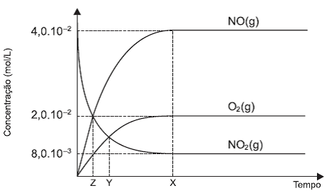

Figure 2-1 Caption

3. System Implementation
Describe implementation here; make sure your description provides sufficient information for the referees to grasp the complexity of your solution.

4. Results
Describe results here...
In this section you should also discuss the validation procedures that were used.

5. Innovation
In this section you should discuss the originality of this work and its innovative aspects.

6. Conclusion
Conclusions here...

References

[1] World Health Organization. Factors regulating the immune response: report of WHO Scientific Group[R]. Geneva:WHO,1970.
[2] CHRISTINE M. Plant physiology: plant biology in the Genome Era[J/OL]. Science, 1998, 281:331-332[1998-0923]. http://www.sciencemag.org/cgi/collection/anatmorp
==================================================================
The text below is not to be included in this report. It was inserted here for reference:
Please observe the Competition Rules:
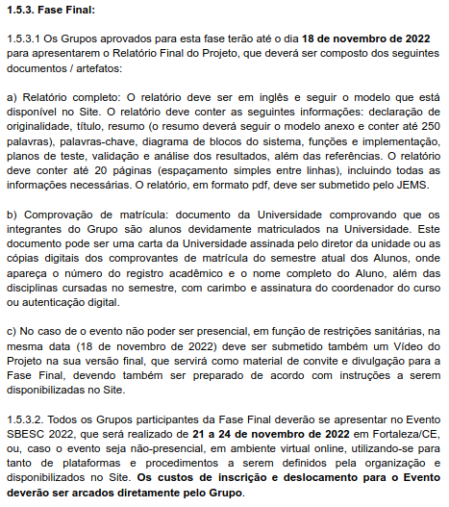IMPORTANTE: o SBESC e a ESC acontecerão de forma presencial

